**TEAM 2 SKIMMING**

**Highlight the article as our example in the class, using this technique**

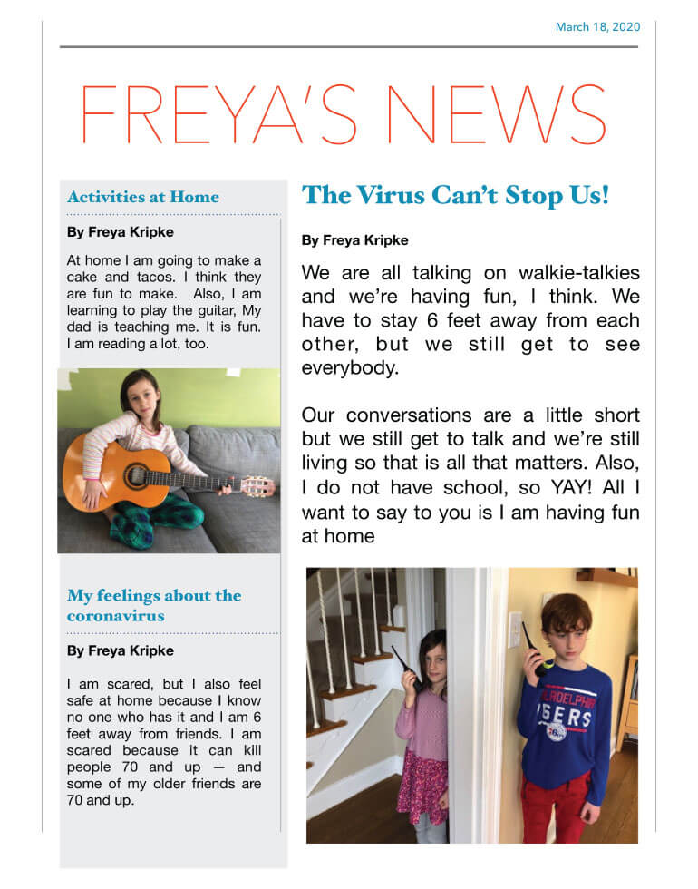**Note: remember is just to have an idea…not all the article.**

**TEAM 3**

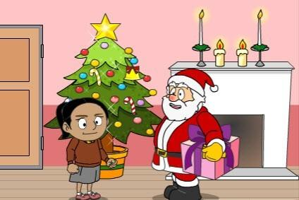**Scanning Activity**

It’s Christmas Eve. Santa and Rudolf are getting ready for Christmas.

Santa puts on his red jacket and his red hat.

‘Ho, ho, ho!’

There are lots of presents in Santa’s sleigh for children around the

world. Now they’re off!

Santa leaves a present for good boys and girls. He eats one mince pie. Then, two, three, four ...

‘Hmm, yum, yum.’

Amy is asleep at home. Santa climbs down the chimney with Amy’s present. But, oh dear ... he is too

fat, he can’t move! ‘Help, Rudolf!’

‘Thank you, Amy. Can you help me take the presents?’ ‘Yes, Santa. Let’s go!’

Amy and Santa fly into the air. They go all around the world with Christmas presents. Amy goes down the chimney and puts the presents under the tree.

‘Catch, Amy.’

‘OK, Santa.’

The sleigh flies back to the North Pole for more presents. Santa’s toy factory is very busy. There are

robots, dolls, balls and teddies.

Amy is at the North Pole. It is snowing. Amy and Rudolf throw snowballs. They have lots of fun.

‘Thank you, Amy. Here’s a special present for you.’ ‘Thanks, Santa. See you again next year!’

‘Thank you, Amy! From Santa.’

**Scanning Activity**

1. **What did Santa put on for Christmas?**

**His red jacket and red hat**

1. **Who did Rudolf help?**

**Santa**

1. **Who did Santa fly into the air with?**

**Amy**

1. **Where is Amy at?**

**At the north pole**

1. **What is Amy and Rudolf doing at the North Pole?**

**They are throwing snowballs.**

# Extensive and Intensive Reading exercise Team 4

# Circle the image that represents for you, extensive reading (red color) and intensive reading (green color)

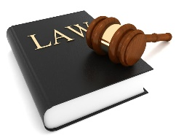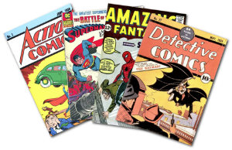

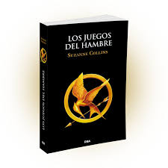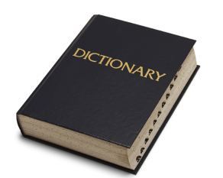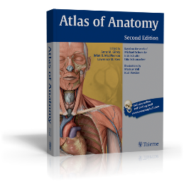

# Read the following text carefully. Write the key words from the text you used to understand the reading

Federal Firearms License Renewal Applications are sent to the mailing address on file 90 days prior to expiration. Renewals must be sent to ATF on or before the date of expiration to be considered timely. Failure to submit a timely renewal form will result in the discontinuance of the operations authorized by your current license and it will be placed “out of business.” A new Federal Firearms License Application will need to be submitted and approved to continue business. We recommend you complete the renewal upon receipt to avoid disruption in your business operations. If your application has been received timely by FFLC, you may continue operations as usual while your application is being processed.

**How do you consider the reading requires Extensive reading or intensive reading? Why?**

Because the renewal of business licenses is a subject related to some mental effort.

**What is the text about?**

Renewal of business licenses

**Write the key words from the text you used to understand the reading**

License

Expiration

Discontinuance

business operations

**Team #5: Getting Meaning from Context**

**Activity:**

**As you read the story, pay attention to the words that are marked in blue, and any hints you might find about the meanings of these words.**

You can’t see it, but the water cycle is always in motion on the earth. This series of events goes round and round, again and again, providing clean, fresh water for the land and seas. As water goes through this cycle, it is sometimes solid ice, sometimes liquid water, and sometimes a gas called water vapor. The energy that drives the water cycle is heat. When heat is added to ice, the ice melts into water. When heat is added to water, it evaporates, turning from liquid into gas. When heat is taken away from water vapor, it condenses, turning from gas into liquid. When heat is taken away from water, it freezes, turning from liquid to solid. The heat from the sun warms the water in oceans and rivers. The water changes into water vapor that rises into the air. High above the earth, the water vapor cools and becomes tiny particles of water that create clouds. As the clouds gather more and more particles of water, the water falls as rain or snow, which are two forms of precipitation. This precipitation is absorbed in the ground or is added to the water in oceans, lakes, and rivers. The cycle is always, constantly, in process, everywhere in the world.

**Select which context clues give a hint to the meaning of each of these words.**

1. **Cycle:**

A. …can’t see it…

B. …on the earth…

C. …series of events goes round and round…

1. **Vapor:**

A. …through this cycle…

B. …a gas…

C. …liquid water…

1. **Evaporate:**

A. …heat is added to water…

B. …heat is taken away…

C. …turning from liquid into gas…

1. **Condense:**

A. …turning from gas into liquid…

B. …it freezes...

C. …turning from liquid to solid…

1. **Particle:**

A. …tiny…

B. …create…

C. …becomes…

1. **Precipitation:**

A. ...particles of water…

B. …rain or snow…

C. …absorbed in the ground…